**How to flash HM-10 firmware on CC41-A**

Date: 13/09/2024

The CC41-A is a low-cost Bluetooth Low Energy (BLE) module designed for various IoT applications. It is a popular choice due to its small size, low power consumption, and versatility. The CC41-A is essentially a clone of the HM-10 module, offering similar functionality but at a lower price point.

Why to flash?

CC41-A lacks external oscillator and its firmware has limited functionality. It doesn’t support all AT commands like HM-10. To make CC41-A compatible with all AT commands, we flash it with genuine HM-10 firmware. After flashing, it will support almost all the AT commands. (Lack of oscillator will not cause any problem as firmware detects if external oscillator available or not. If not available, it uses internal oscillator).

We get multiple resources to help with flashing, but all of them require Arduino UNO. If you have it you can refer this [link](https://forum.arduino.cc/t/how-to-flash-genuine-hm-10-firmware-on-cc2541-make-genuine-hm-10-from-cc41/379343?page=8) or this this youtube [tutorial](https://www.youtube.com/watch?v=ez3491-v8Og). But in this document, we will use ESP32 to flash firmware.

Requirements:

Hardware:

* ESP32 Wroom
* CC41-A
* FTDI
* Jumpers, soldering iron (optional)



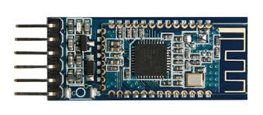

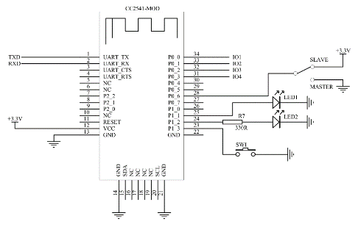

Software:

* Arduino IDE (preferred 1.6.6)
* CCLoader Arduino sketch: [link](https://github.com/y-runwal/CC41-A/blob/main/HM10_firmware.ino)
* CCLoader Windows program: [link](https://github.com/y-runwal/CC41-A/blob/main/CCLoader.exe)
* HM-10 Firmware: [link](https://github.com/y-runwal/CC41-A/blob/main/CC2541hm10v540.bin)

Steps:

* Download files and place them in same folder
* Upload CCLoader Arduino sketch to ESP32 using Arduino IDE
* Make connections like follows

|  |  |  |
| --- | --- | --- |
| Name | ESP32 GPIO | CC41-A |
| Debug_Clock (DC) | GPIO5 | 7 |
| Debug_Data (DD) | GPIO15 | 8 |
| Reset | GPIO4 | 11 |
| LED (not mandatory) | GPIO2 | - |
| Vcc | 3v3 | Vcc |
| GND | GND | GND |

To make connection, you can refer following

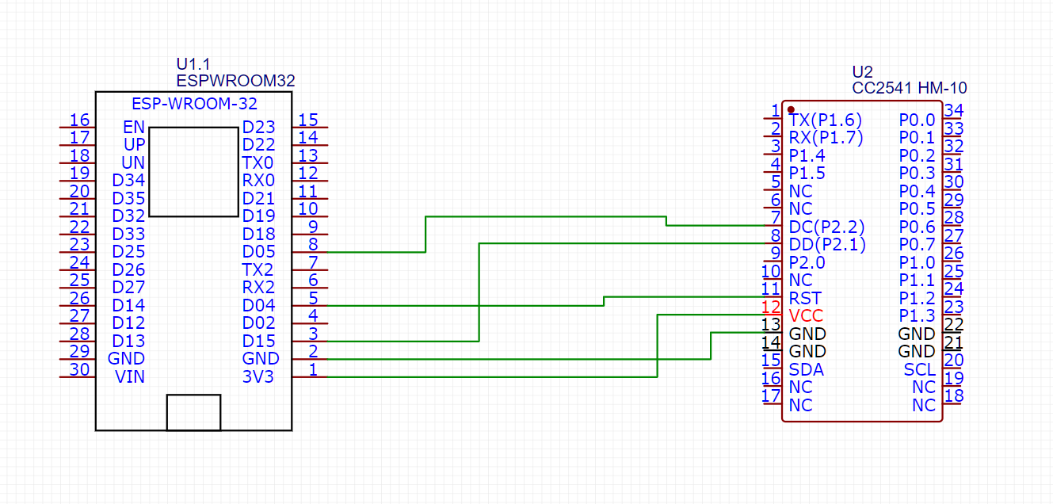

Also for the wiring you can solder wire to the pins or harder, you can use dupont wire and manually hold the wires on the pads.

* Open directory where files are saved/downloaded and open CMD prompt over there.
* Type following command in prompt and hit enter.

CCLoader.exe <COM port of ESP32> <Firmware.bin> 0

E.g., If com port of esp32 is 6 and firmware bin file’s name is HMSoft.bin, then command will be,

CCLoader.exe 6 HMSoft.bin 0

* Wait till successful flashing

Cmd will look like this and finally you can see message like

File closed!

Comport closed!

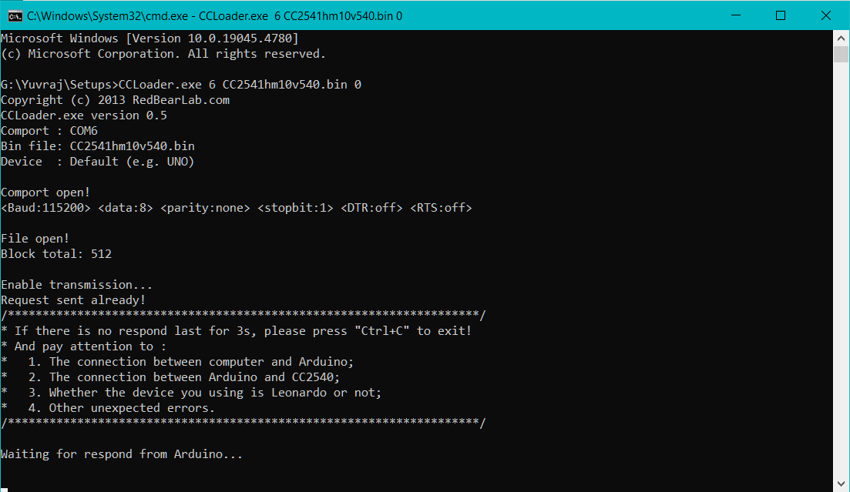

* It’s done. Don’t forget to check red blinking LED on CC41-A to confirm flashing.
* Since, firmware is changed to HM-10, now it will not except Line mode terminal for AT commands. You can use Arduino IDE 1.6.6 to test AT commands. Just go to Tools -> Port (Select appropriate port). Press Ctrl+Shift+M to open serial monitor.

Now you can use almost every AT command supported by HM-10 in CC41-A.

References:

1. [How to flash genuine HM-10 firmware on CC2541](https://forum.arduino.cc/t/how-to-flash-genuine-hm-10-firmware-on-cc2541-make-genuine-hm-10-from-cc41/379343?page=8)
2. [HOW TO: Flash the HM-10 firmware on to CC41-A / CC2541 - Bluetooth 4.0](https://www.youtube.com/watch?v=ez3491-v8Og&t=4s)